[Maven Project Using Eclipse How to build a Proje - YouTube](https://www.youtube.com/watch?v=BQgL5LzTGfA)

[Maven Theory Explanation.docx](Maven%20Theory%20Explanation.docx)

How to create a Maven project in Eclipse and to create Build file.

Open Eclipse---- please click on help tab

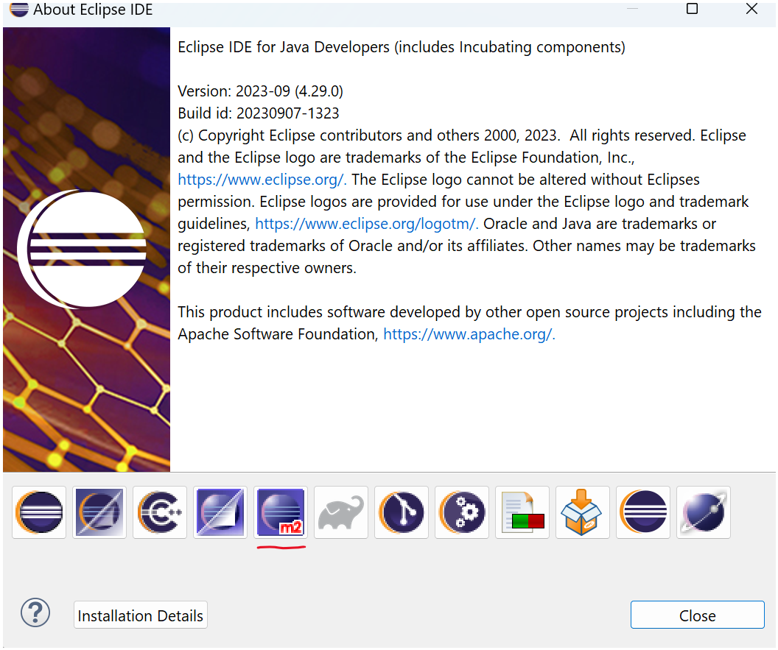

Already Maven file is available along with Eclipse.

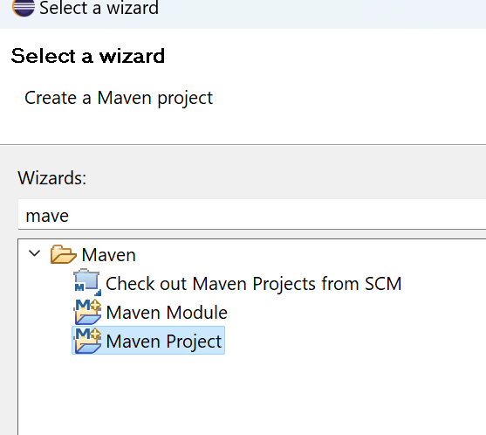

If it is not showing then we need to install the Maven plug ins.

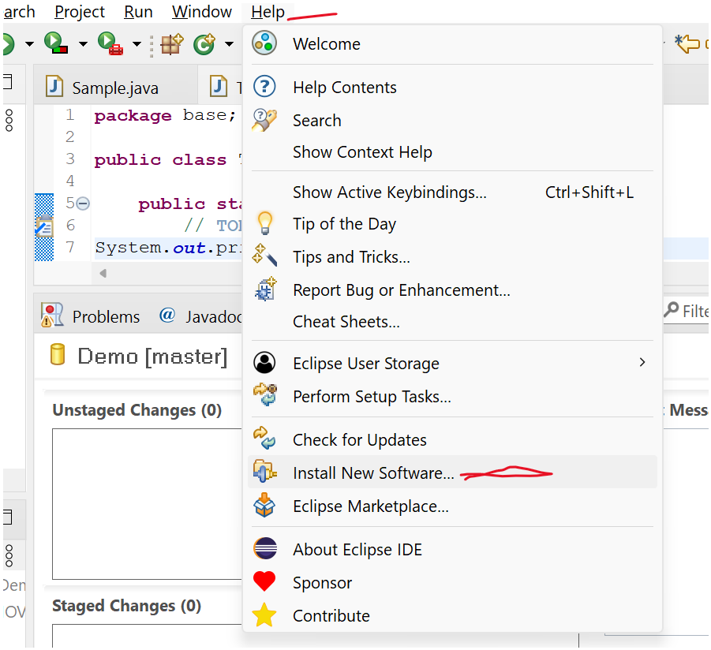

<https://download.eclipse.org/technology/m2e/releases/2.2.0/>

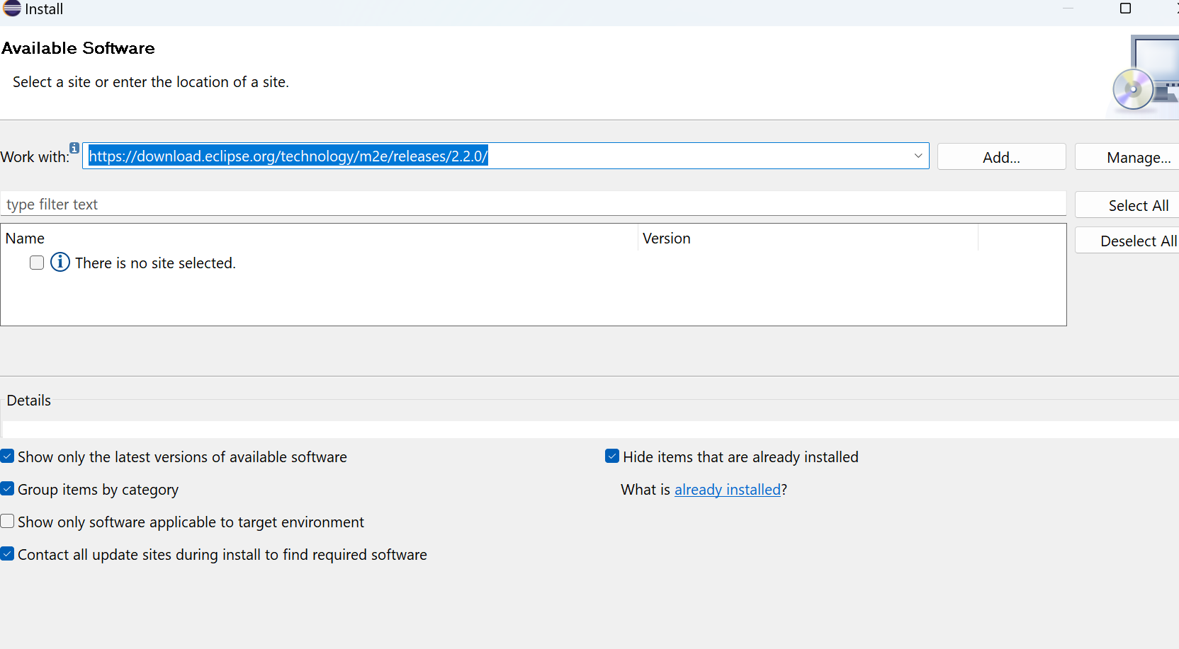

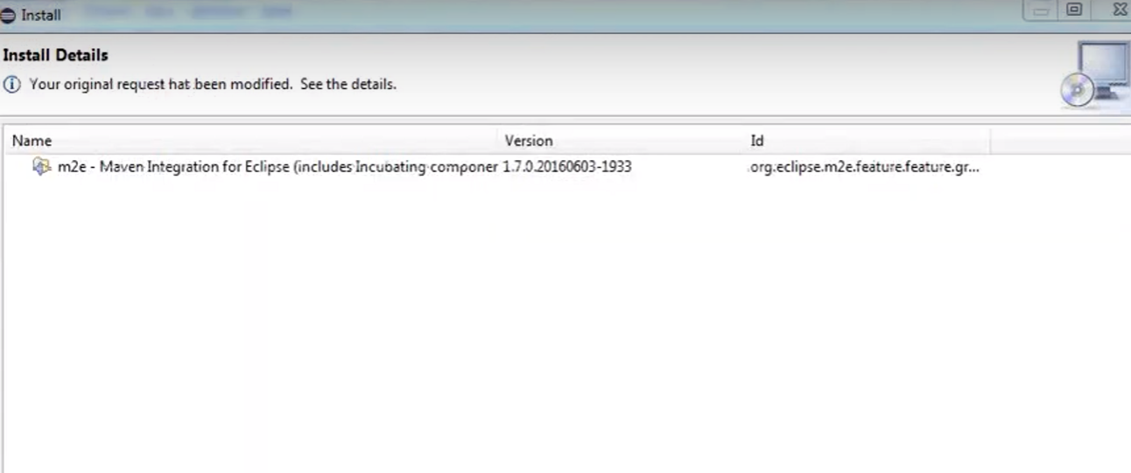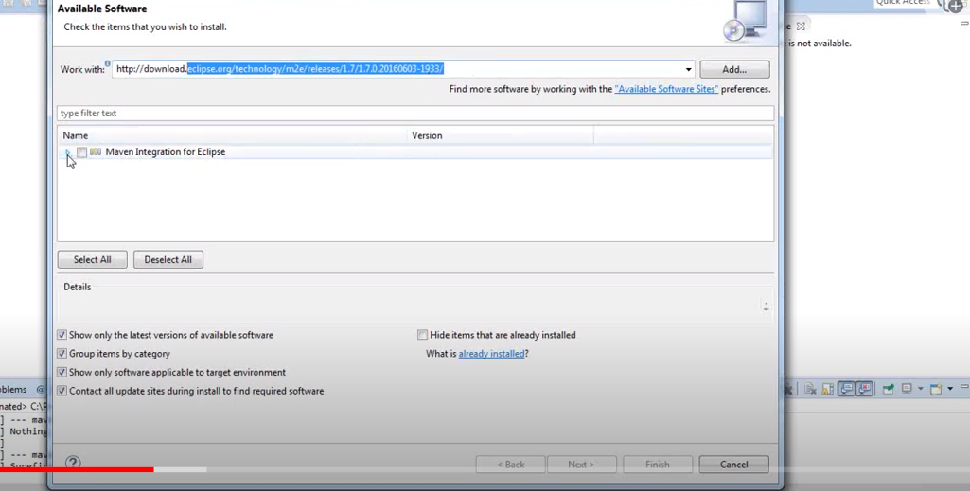

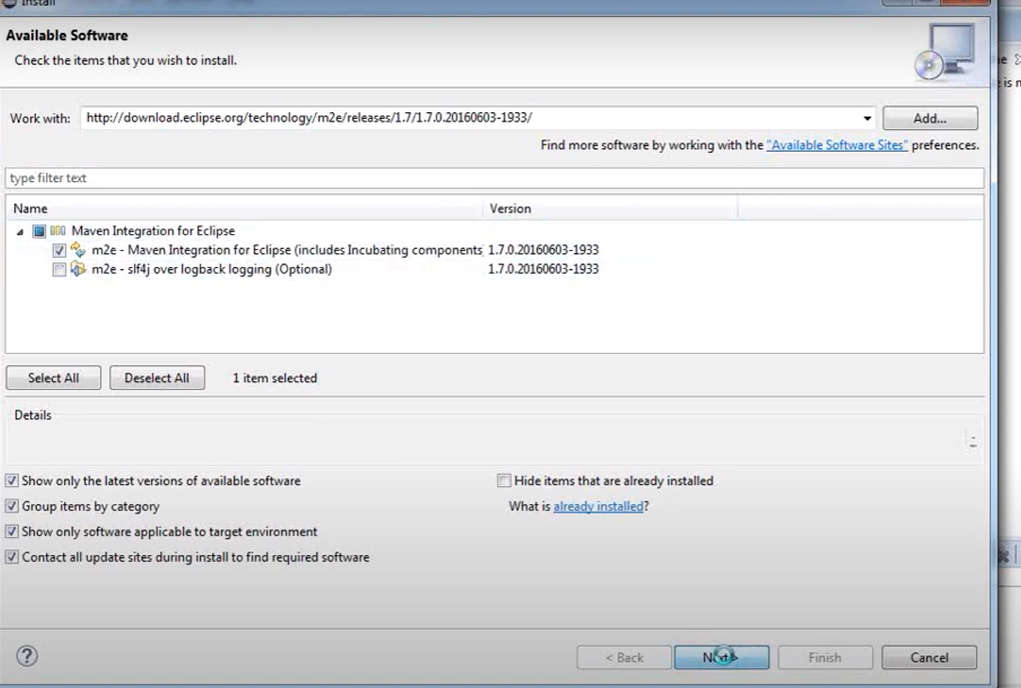

Create a Maven project in eclipse

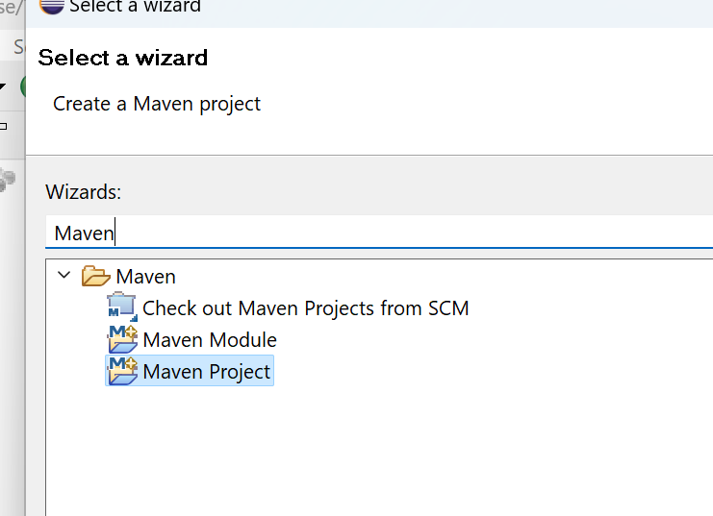

Select Maven Project.

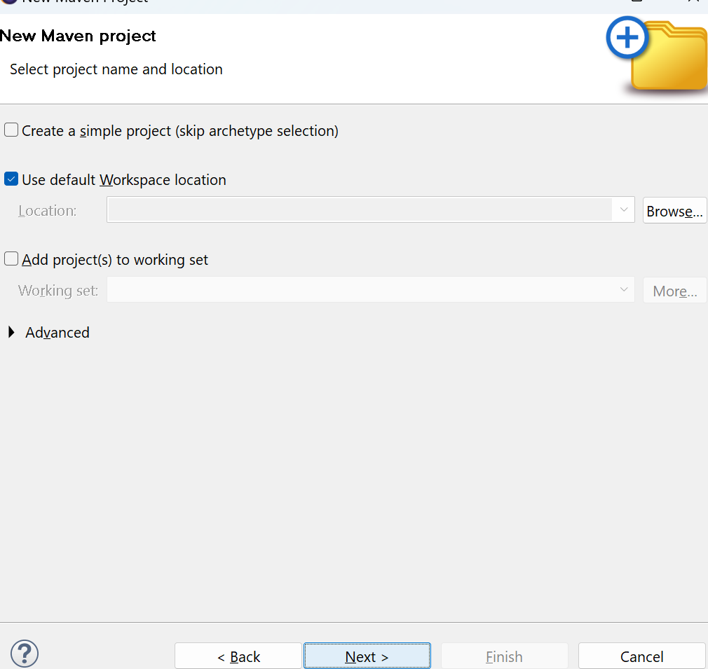

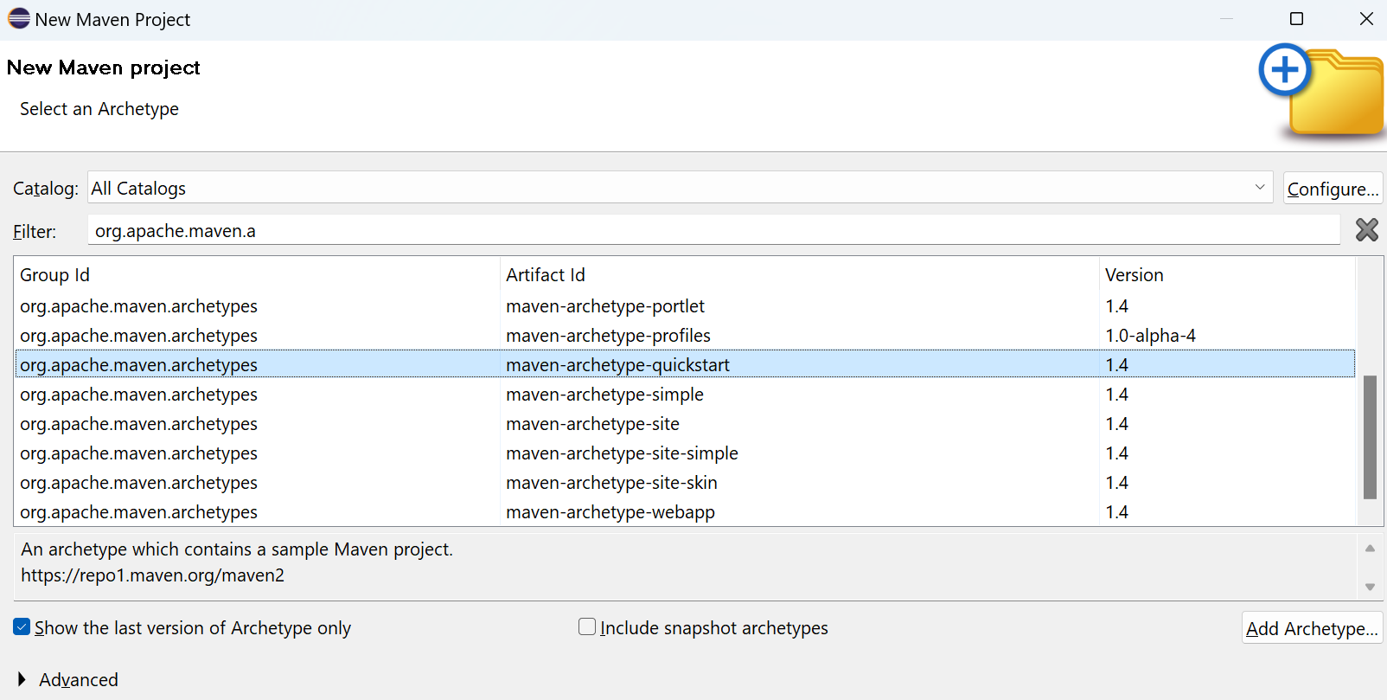

[Maven archetypes.docx](Maven%20archetypes.docx)

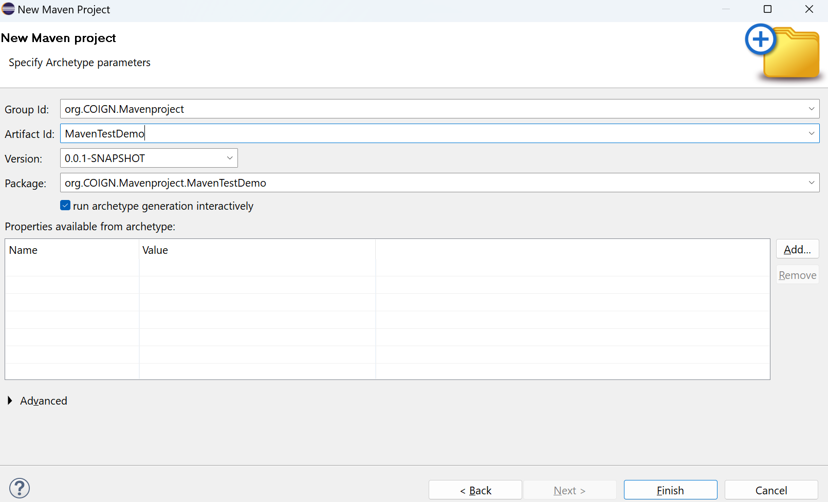

[Maven GroupID and Artifacts.docx](Maven%20GroupID%20and%20Artifacts.docx)

It will take lot of time for the first time as it should load lot of files:

You view the status in console.

[Maven Project.docx](Maven%20Project.docx)

Confirm properties configuration:

groupId: org.COIGN.Mavenproject

artifactId: MavenTestDemo

version: 0.0.1-SNAPSHOT

package: org.COIGN.Mavenproject.MavenTestDemo

Y: : Y

[INFO] ----------------------------------------------------------------------------

[INFO] Using following parameters for creating project from Archetype: maven-archetype-quickstart:1.4

[INFO] ----------------------------------------------------------------------------

[INFO] Parameter: groupId, Value: org.COIGN.Mavenproject

[INFO] Parameter: artifactId, Value: MavenTestDemo

[INFO] Parameter: version, Value: 0.0.1-SNAPSHOT

[INFO] Parameter: package, Value: org.COIGN.Mavenproject.MavenTestDemo

[INFO] Parameter: packageInPathFormat, Value: org/COIGN/Mavenproject/MavenTestDemo

[INFO] Parameter: package, Value: org.COIGN.Mavenproject.MavenTestDemo

[INFO] Parameter: groupId, Value: org.COIGN.Mavenproject

[INFO] Parameter: artifactId, Value: MavenTestDemo

[INFO] Parameter: version, Value: 0.0.1-SNAPSHOT

[INFO] Project created from Archetype in dir: C:\Users\LENOVO\eclipse-workspace_new\MavenTestDemo

[INFO] **[1m------------------------------------------------------------------------**[m

[INFO] **[1;32mBUILD SUCCESS**[m

[INFO] **[1m------------------------------------------------------------------------**[m

[INFO] Total time: 17.400 s

[INFO] Finished at: 2023-09-24T05:40:01+05:30

[INFO] **[1m------------------------------------------------------------------------**[m

Project folder is created and maven is taken care of all other things. Only we need to create a java files.

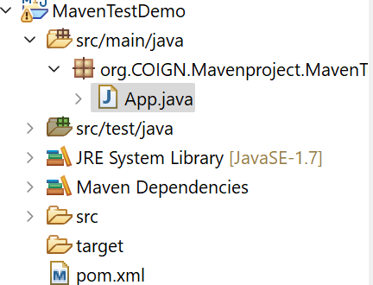

Click on pom.xml

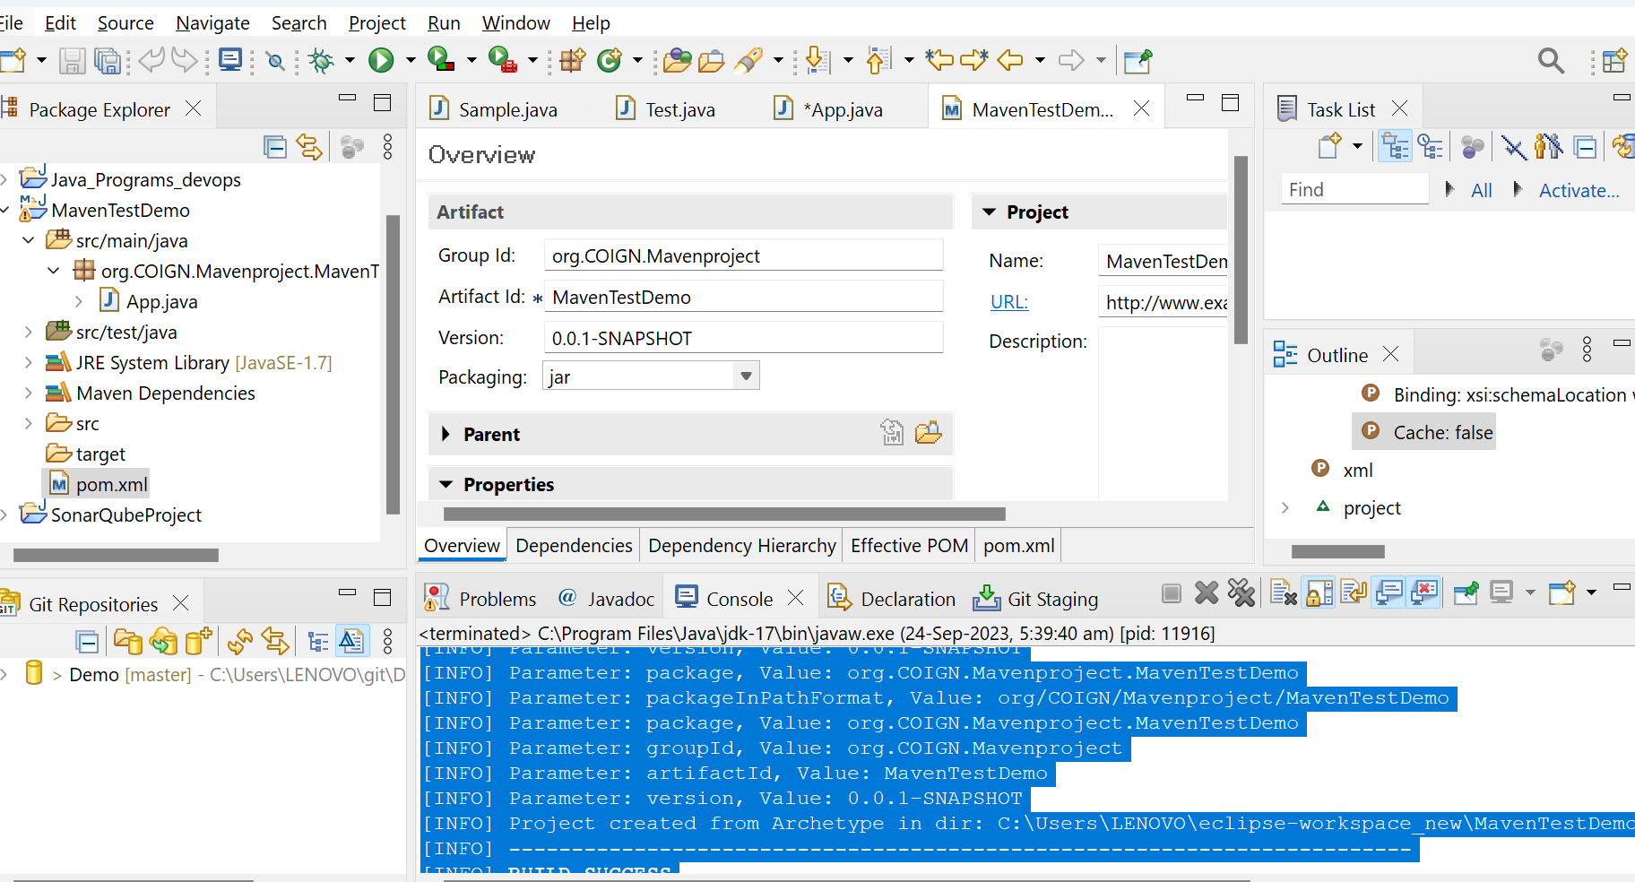

[Maven POM.docx](Maven%20POM.docx)

Right click on the pom.xml

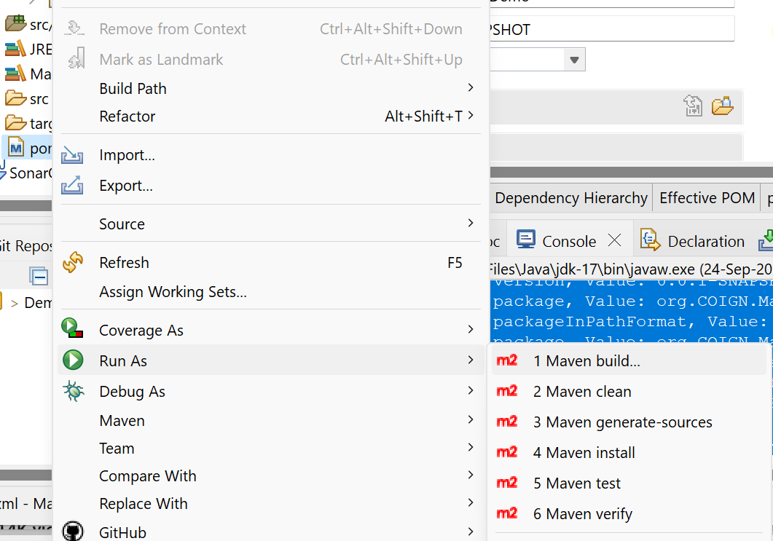

Click on Maven Build

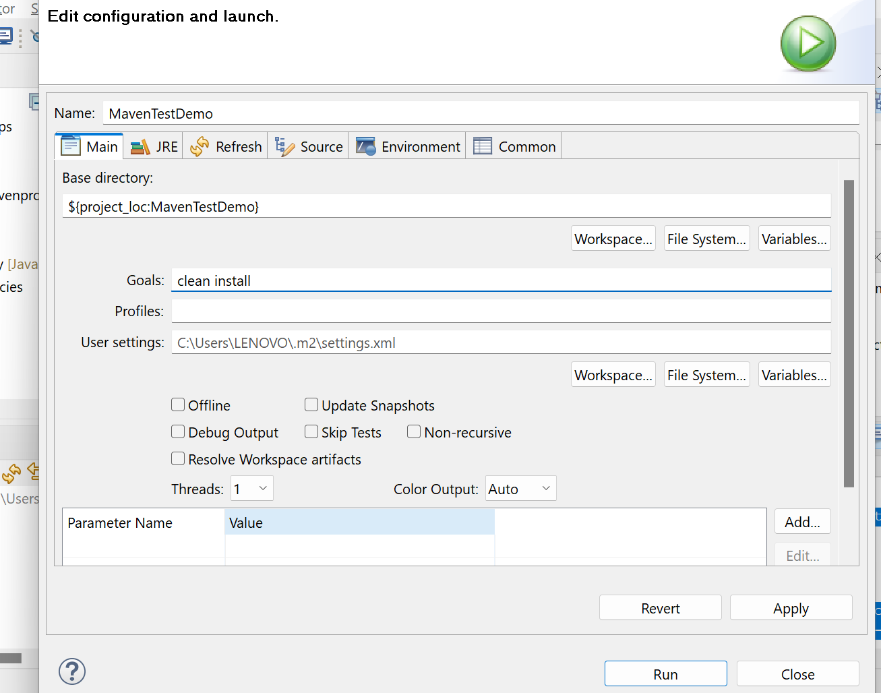

Add command clean and install and click on RUN

[Maven Commands.docx](Maven%20Commands.docx)

Now See the console and it will give the status of process Upon completion.

[excutable scripts.docx](excutable%20scripts.docx)

C:\Users\LENOVO\eclipse-workspace_new\MavenTestDemo\target….. In this location you can find the Build file.

You can find all the files.

So go the command prompt

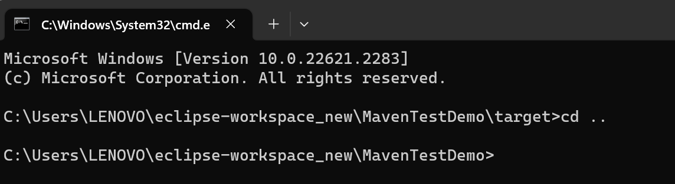

java -cp ./target/MavenTestDemo-0.0.1-SNAPSHOT.jar org.COIGN.Mavenproject.MavenTestDemo.App

Syntax is java -cp ./target/generated Jar file GroupId.artifactId.className.

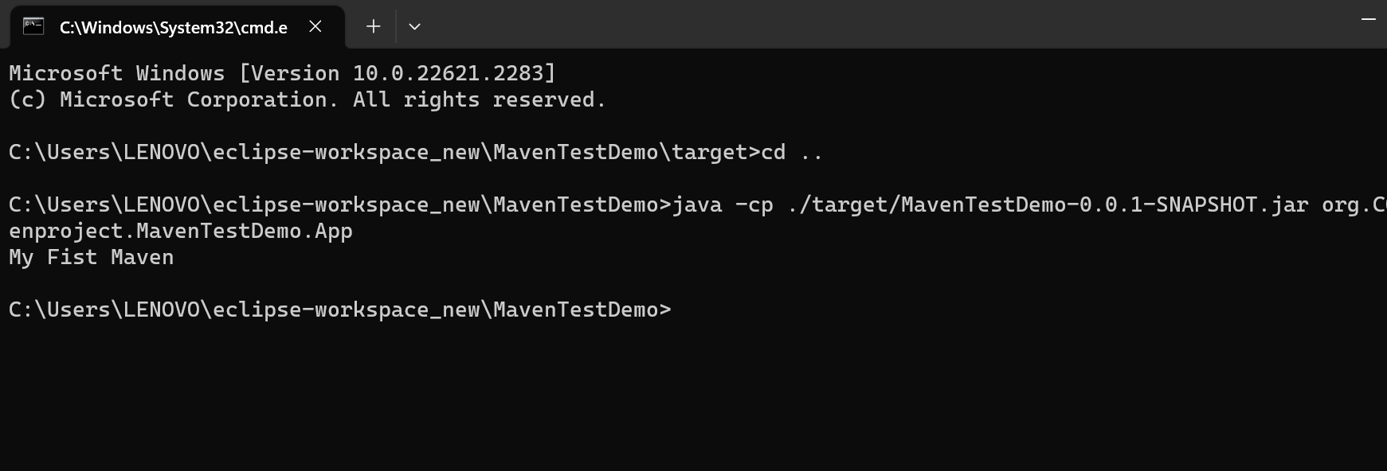

[Java CP Command.docx](Java%20CP%20Command.docx)